Early Modern German Culture

The seminar meets four times this term on Wednesday 2-4 in the Pontigny Room, St Edmund Hall, followed by tea and cake. It is held this year in collaboration with the Oxford Brookes School of History, Philosophy and Culture.
Please contact edmund.wareham@seh.ox.ac.uk for further information.

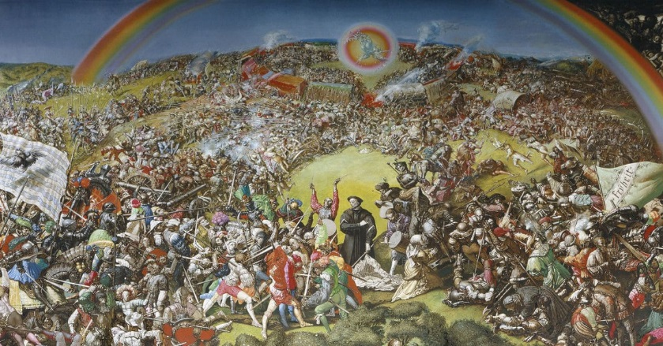

Week 2 Wednesday 29 January, 2 to 4pm
Róisín Watson (Mansfield/Oriel) Sharing Space between Lutherans and Catholics in Early Modern Württemberg

Week 4 Wednesday 12 February, 2 to 4 pm
Johannes Dillinger (Oxford Brookes) Ritual Magic, Spellbooks and Mining

Week 6 Wednesday 26 February, 2 to 4 pm
Jeannette Kamp (History Faculty) Contested Mobilities: Gender and Banishment in Early Modern Frankfurt am Main

Week 8 Wednesday 11 March, 2 to 4 pm, Perspectives on Early Modern Germany from the GDR, chaired by Paul Betts (St Anthony’s)
Marcus Colla (Christ Church) Luther, Müntzer and the GDR's "Historical Turn" in the 1970s
Tina Mendelsohn (Lincoln) The Making of the GDR Woman Artist Past and Present
Bethan Winter (St Peter’s) Baroque to the Future: The SED’s Teleological Argument for the Socialist Project and the Influence of Bach and Handel on East German Musical Culture

Seminar Organisers: Louis Morris, Lyndal Roper, Edmund Wareham, Róisín Watson

