On the 20th of April, Jacob Fordham (AMES DPhil, University College) and Hannah Dongsun Lee (History DPhil, St Edmund Hall) organised the conference ‘Authority and the Global Early Modern: Translation and Transformation,’ generously supported by the CEMS event funding. Our conference featured the emerging scholarship of early modern global history and the new approaches and methodologies surrounding it. In particular, we tried to address that early modern global encounters may be discussed more productively if we understand them in terms of connection, interaction, and negotiation, rather than competition, clash, or one-way reception. In order to explore this possibility, we chose the concept of authority and called for papers that examined the ways in which the early modern conditions of global connectivity projected, translated, and transformed the ideas and representations of authority.

We had eight excellent papers from five institutions that answered our calls in various ways. We divided the papers into three panels, each highlighting ‘The intellectual challenge of non-Western authorities,’ ‘The global projections of authority,’ and ‘The construction of political authority in an age of global encounters.’ The panels were wonderfully chaired by our own Professors Giuseppe Marcocci, Saliha Belmessous, and Erica Charters. The keynote speaker was Professor Leigh Jenco (LSE) who has been pioneering the field of global history (among others) and coined powerful terms such as ‘history in between’ and ‘co-production of knowledge’ on a global scale.

The first panel, ‘The intellectual challenge of non-Western authorities,’ chaired by Professor Marcocci, discussed how the primarily ‘Western’ figures experienced the world beyond their familiar intellectual cultures and negotiated their understanding of conventional canonical writings. All speakers illustrated the complex process of reframing traditional authorities in the face of new knowledge, languages, and material conditions. The chair facilitated discussions on the nature of knowledge and the exact character of encounters that shaped those experiences.

The second panel, ‘The global projections of authority,’ chaired by Professor Belmessous, focused on the centrifugal directions of representing royal and cultural authorities. The speakers showed not only the evolving representation of authorities outside the political and cultural ‘centres,’ but also the importance of the physical materials in understanding early modern authority. The chair enriched the discussion by suggesting the multicentred nature of the production of authority.

Before the third panel, Professor Jenco gave an enlightening keynote lecture on her recent research about folksongs and the construction of national identity in China. Focusing on the emotional link between past and present put forward by a folksong collector and historian, Professor Jenco suggested the place of human senses in constructing authority, and ways to think about popular authority without the Western languages of resistance and subversion.

The final panel, ‘The construction of political authority in an age of global encounters,’ chaired by Professor Charters, reconsidered diplomatic relations as a malleable and co-productive process rather than a competing or hierarchical one. The speakers highlighted the government-level conversations and interactions that shaped political institutions, borders, and objects. The chair asked about the idea of ‘success’ across these schemes, and stimulated the discussion about the evolution of diplomatic relations and the idea of location in global history.

We had more than thirty audiences throughout the day, who were served coffee and sandwiches purchased with the CEMS fund. Thanks to the fund, we were able to maintain lively conversations among all participants over lunch and break. We hope that the conference offered a place to explore new directions in global history and to meet scholars from different areas and institutions. We really appreciate our chairs for facilitating the panels with exceptional grace, and Professor Jenco for being extremely engaging throughout the conference.

Professor Jenco’s Keynote Lecture
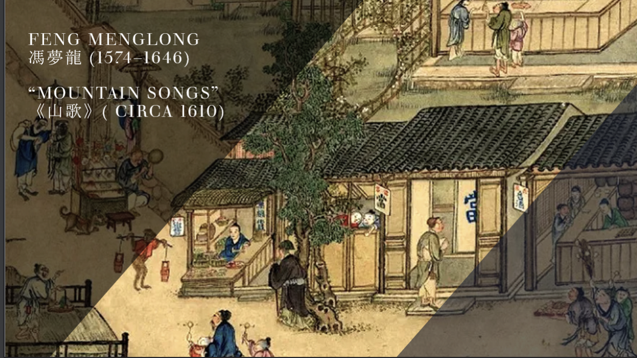

John Senex, Map of the World (1721)
