CEMS Conference Funding: Conference Report
Conference Organiser Details
1. Conference Organisers (including titles):  Lea Cantor  (Co-organisers: Dr Josh Platzky Miller, Mr Jonathan Egid, Dr Dmitri Levitin, Mr Sihao Chew, Ms alicehank winham) | 2. Institution (including department title):  Lea Cantor: Doctoral Candidate, Faculty of Philosophy, University of Oxford
3. Address:  Worcester College  Walton Street  OX1 2HB Oxford  UK | 4. E-mail: lea.cantor@philosophy.ox.ac.uk  5. Telephone: +447709503200
6. Name of finance administrator (e.g., person who manages conference accounts):
Lea Cantor in collaboration with the Faculty of Philosophy finance officer, Steve Wann (stephen.wann@humanities.ox.ac.uk)

E-mail: lea.cantor@philosophy.ox.ac.uk
7. Conference Website Address: https://questioningwesternphilosophy.weebly.com/

Conference Details
8. Date of Report: 3/July/2023 | 9. Name of person filling out form:  Lea Cantor  E-mail: lea.cantor@philosophy.ox.ac.uk
10. Conference Title:  Questioning ‘Western Philosophy’: Philosophical, Historical, and Historiographical Challenges | 11. Location: Sultan Nazrin Shah Centre, Worcester College, University of Oxford 12. Date(s) of Conference: 28-30 April 2023
13. Graduate Conference:  No  (Not exclusively: organizers are partially graduate students, and CfA was aimed at graduate students and early-career researchers, while invited speakers are a mix of junior and senior academics) | 14. Grant Amount: £200

Conference Details (continued)
15. Detailed summary and assessment of the conference:

Questioning ‘Western Philosophy’ was the first international conference dedicated to the subject of how the idea of ‘Western philosophy’ was constructed, and the legacies of this construction on subsequent philosophy and intellectual history. The conference took place in April 2023 at Worcester College, University of Oxford. The invited speakers were Prof. Linda Martín Alcoff, Prof. Peter Adamson, Prof. Lucy Allais, Prof. Robert Bernasconi, Prof. Souleymane Bachir Diagne, Prof. Lewis Gordon, Dr Kimberly Ann Harris, Prof. Monika Kirloskar-Steinbach, Prof. Catherine König-Pralong, Prof. Lin Ma, Prof. Christoph Schuringa, and Dr Yoko Arisaka. The speakers selected through a competitive CfA were Dr ​Lilith W. Lee, Dr Saloni de Souza, Sarah Bernard-Granger, ​Allan M. Hillani, Dr ​Lerato Posholi, Dr ​Kadir Filiz, and Dr ​Daniel James Smith. In addition, four of the organizers gave papers: Lea Cantor, Jonathan Egid, Dr Josh Platzky Miller, and Dr Dmitri Levitin. Chairs included the current Chair of the Philosophy Faculty Board at Oxford, Professor Ursula Coope; the current Director of Graduate Studies in the Philosophy Faculty at Oxford, Prof. Luca Castagnoli; Prof. Faridah Zaman (History, Oxford); Dr Alesia Preite (Philosophy, Oxford); Maya Krishan (Philosophy, Oxford); and Justin Holder (Philosophy, Oxford).

Overall, the conference was a resounding success, and we have received strongly positive feedback from speakers and guest attendees. Building on work from, inter alia, the history of philosophy, global intellectual history, intercultural and comparative philosophy, critical philosophy of ‘race’, and decolonial studies, the conference explored the concept of ‘Western Philosophy’ from philosophical, historical, and historiographical perspectives. It brought together scholars working across multiple philosophical traditions from around the world, and drew together many of the specific debates that have taken place within these fields with a view to exploring their broader significance for our understanding of philosophy and its history.

The conference speakers tackled several of the thorny issues at stake: the legitimacy of descriptors, such as ‘Western’, when applied to philosophy (especially if considered a universal practice of human reason); the historical circumstances for the emergence of the idea of ‘Western Philosophy’ and the narratives associated with it; and the ways in which disciplinary histories of philosophy often presents ‘Western Philosophy’ as equivalent to ‘Philosophy’ as such, implying the exclusion of non-European philosophical traditions from the mainstream 'canon'.

Several speakers explored the legitimacy debates which have thus far been reserved for so-called ‘non-Western’ philosophical traditions. A number of contributions also challenged the linear narrative that presents the history of philosophy as a continuous, progressive, self-standing development from the ancient Greeks to contemporary Euro-America. Several speakers also drew attention to and expanded upon recent scholarship highlighting the erasure of African and Asian philosophical sources, starting especially in 18th-century European historiography, and the subsequent repainting of philosophy as purely European and, in time, White. We achieved a clearer picture of how these dynamics shaped or even grounded the idea of ‘Western Philosophy’ which emerged over the 19th and 20th centuries. A range of contributions, from Catherine König-Pralong and Lewis Gordon to Sarah Bernard-Granger and Yoko Arisaka, also tackled aspects of the impact of colonialism and how its legacies have contributed to the construction of ‘Western Philosophy’. We thus had critical debates about the origins and rapid ascendancy of the idea of ‘Western Philosophy’, pinpointing key historical moments in the genealogy and dissemination of the idea itself.

Several speakers proposed that we shift the focus to issues in metaphilosophy: to the broad question of what makes something philosophical in the first place. In other presentations, we heard about some of the double-standards that are imposed on philosophizing due to narratives of ‘Western Philosophy’ (Kadir Filiz, Allan Hillani, Lin Ma), such as delimiting which languages are considered ‘philosophical’ and claiming textuality and Greek-responding philosophy as a uniquely European heritage (Souleymane Bachir Diagne).

A range of speakers brought out the impact of the problematic narrative of ‘Western Philosophy’ in specialist work in the history of philosophy. Lea Cantor and Robert Bernasconi demonstrated that teleological narratives of progressive rationalization or secularization – which gained traction especially in late-18th-century Germany – still have a strong hold in contemporary philosophy, and directly underpin exclusions cutting across schools of thought and time periods (Cantor showed their continued impact on the field of ancient philosophy; Bernasconi highlighted the stakes for late modern philosophy and changing attitudes to Chinese and Indian philosophy in the period). Others, such as Monika Kirloskar-Steinbach, Lewis Gordon, and Allan Hillani, pointed to how ‘Western Philosophy’ narratives obscure or even undermine philosophical work done across the world – creating a problem not only for the history of philosophy, but for philosophy as such.

Several speakers, such as Christoph Schuringa, Josh Platzky Miller, and Linda Martín Alcoff, analyzed the idea of ‘Western Philosophy’ as a political project, which ought to be critiqued in this light. Others, including Lilith W. Lee, Saloni de Souza, and Allan Hillani, presented critiques of narratives attributed to ‘Western Philosophy’ from historical figures from around the world ranging from Latin America, Africa, South and South-East Asia.

As anticipated, several speakers provided arguments calling for the abandonment of the category of ‘Western Philosophy’, including Lucy Allais, Peter Adamson, and Josh Platzky Miller. Others, including Linda Martín Alcoff and Christoph Schuringa, argued that we might instead hold on to the category of ‘Western Philosophy’, but only insofar it ‘names a problem’. Alternatively, it was suggested that we abandon the category of ‘Western Philosophy’ but use a different name that problematizes it more explicitly – e.g. ‘Eurocentric philosophy’, as proposed by Josh Platzky Miller. The challenge this debate brought into focus was the problem of acknowledging the fact that the idea of ‘Western Philosophy’ has a hegemonic hold, and that it is to this extent a reality, while at the same time recognizing that using the label risks reinforcing and perpetuating the falsehoods on which the idea relies.

The conference also implicitly touched upon the prospects to which critiquing the idea of ‘Western Philosophy’ gives rise for the future of philosophy. These included the idea that decolonial critique is often a subtext of challenges to the idea of ‘Western Philosophy’; that an adequate critique of ‘Western Philosophy’ must also take into account and probe gendered exclusions; that relevant metaphilosophical debates will need to grapple with the challenges of (often implicit) methodological essentialism; that disciplinary ‘decadence’ in philosophy ought to be interrogated, and questions of interdisciplinary and cross-cutting engagements encouraged. We also discussed the question of how all of this is likely to affect daily as well as intergenerational practices: how do we implement such critiques in teaching? How does this shape research? How does the university relate to non-university environments? How is philosophy used politically and what is the role of philosophy in social struggles? How does philosophy risk contributing to the reproduction of imperial systems? Questioning ‘Western Philosophy’ opened new ground for exploring these debates through multifaceted critique of the narratives of ‘Western Philosophy’ itself.

Feedback from attendees

One of the invited speakers wrote to us after the end of the conference “to thank you [the organizers] for including me in the conference and also for all the meticulous work you put into it to make it such a success.” Another invited speaker wrote to us saying that “I enjoyed the exchange and look forward to the [post-conference proceedings] publication.” Another invited speaker wrote: “thanks so much for putting on such a wonderful conference. I know it was a lot of work. It was worth it, as people are so impressed and relieved so many scholars are working on these matters.” Another invited speaker wrote: “Thanks again---I got a lot out of the conference, and will think about these issues for some time to come.” Yet another invited speaker wrote to us saying “Thanks for an amazing conference! And many congratulations on your outstanding organisation, and bringing so many people together.”

One of our early career speakers selected through the CfA wrote: “thank you so much for this wonderful organization. It was a great honor for me to be a participant in it. This was, I think, the first one directly focused on questioning "Western philosophy" in many aspects with many different scholars. I am sure that it will be mentioned in the future like Bandung conference. All talks were so nice and I learned a lot from them. Moreover, I met with many scholars whose work I admire and also whose work I am going to read as soon as possible.” Another early career speaker selected through the CfA wrote: “Thanks again for a fantastic conference, and for some great conversation [...]. I learned a lot, made some great new connections, and strengthened some old ones.”

One of the PhD-level speakers selected through the CfA wrote: “It was a great pleasure to be part of this conference and you have done an excellent job putting up this conference!”

One retired political theorist who was an in-person attendee said that “you [the organizers] [...] did a wonderful job organising the conference, and I found it very stimulating. There were a great range of papers, and bookending the conference with Lucy Allais and Linda Martin Alcoff worked really well.” They suggested that the organizers might “put together something like an AHRC project proposal forefronting the need to encourage and enable other voices (marginalised and silenced by the power differential defined by analytical philosophy), as a means of overcoming the dominance of analytical philosophy but not seeking to abolish it.”

A PhD candidate who was part of our online audience wrote to us saying “Congratulations on your success in the academic conference of Questioning ‘Western Philosophy’: Philosophical, Historical, & Historiographical Challenges (28-30 Apr 2023)” and offered to help translate some of the conference-related outputs into Chinese in an academic journal in China.

A professor of philosophy who attended the conference online wrote to one of the organizers saying: “I attended your conference talk this morning virtually, and wanted to say how much I enjoyed it - I think these lines of research are hugely important.”

One of our chairs wrote to let us know that “The two panels I heard gave me a lot of food for thought. I look forward to seeing the volume [gathering conference papers] you’re [...]preparing!”

Follow-up potential of the conference

We intend to submit an edited volume proposal gathering conference proceedings to a top academic publisher. (We have already received expressions of interest from a series editor at Oxford University Press and from a philosophy editor at Bloomsbury.) This will be the first ever edited volume dedicated to the subject of how the idea of ‘Western philosophy’ was constructed, and the legacies of this construction on subsequent intellectual life.

As noted above, one conference attendee who sent us feedback suggested that the organizers consider putting together something like an AHRC project proposal “forefronting the need to encourage and enable other voices (marginalised and silenced by the power differential defined by analytical philosophy), as a means of overcoming the dominance of analytical philosophy but not seeking to abolish it.” They added that “The project could be structured in terms of inviting and supervising a set of say 6-8 PhD and Post Doc researchers to articulate voices from different traditions, under the auspices of research on the central theme carried out by the principal investigator, highlighting the concepts of voice, discourse and hybridity.” They remarked that “eliciting other voices is already underway in an ad hoc way, as [our] conference demonstrated. But a project like this could facilitate further voices, from those engaged in discourses within subordinated philosophical traditions (Chinese, Indian, Islamic, African, but also someone with knowledge of Australian indigenous cosmology etc) in a fruitful way.”

BPA/SWIP Good Practice Scheme for gender equality: conferences and seminars

Without compromising the standards of our conference, we made the following efforts to adhere to the BPA/SWiP Good Practice Scheme for gender equality.
Of our 23 speakers, we invited 7 female speakers (Profs. Lucy Allais, Monika Kirloskar-Steinbach, Linda M. Alcoff, Lin Ma, and Catherine König-Pralong, and Drs Yoko Arisaka and
Kimberly Ann Harris) and selected 4 through the CfA – making 12, including the lead organizer, Lea Cantor.
We ensured overall gender balance among our 8 panel chairs: Prof. Prof. Ursula Coope, Maya Krishnan, Lea Cantor, and Prof. Faridah Zaman.
We also offered the provision of childcare facilities, through the BSHP’s £500 childcare grant.

BPA Environmental Travel Scheme

In addition to the five organizers based in the UK, 8 of our speakers traveled from within the UK (London) and Europe (Paris, Amsterdam, Basel, Hildesheim). We encouraged them to
travel to Oxford by train; 4 were able to.
Given the nature of the conference, we made efforts to ensure that the invited speakers would not be composed exclusively of European scholars by inviting a number of renowned
scholars globally. As organizers, we also believe that a primarily in-person event facilitates the kinds of exchanges necessary for the conference to serve as a ground-breaking and
comprehensive contribution to knowledge production about the history of philosophy. This means that many of our speakers had to travel to the UK from outside of Europe, and thus air
travel will be necessary for most of the remaining speakers.
However, in the interest of making the conference maximally accessible, we made the event ‘hybrid’ (online-offline), with a livestream recording running throughout the conference. We
gave all speakers, including those selected through the CfA, the option to give their talks by video-link, and fully supported those who make this decision for environmental reasons. Three
of our speakers joined by video link: one from California, one from New York, and one from Munich. We also encouraged participants where possible to ‘double-up’, attending other
events while in the UK such that they did not fly solely for the conference.

BPA/SWiP Guidelines for Accessible Conferences

We held the conference in the Sultan Nazrin Shah Centre Auditorium (Worcester College, Oxford), which is fully wheelchair accessible. We also offered free online attendance of the
conference through a livestream recording.
16. Brief overview of the publicity methods used to promote the conference:

We advertised the conference through the following organizations/websites/mailing lists:
- Philos-L (mailing list)
- Philiminality Oxford (website & mailing list)
- Oxford public philosophy Newsletter & social media
- Faculty of Philosophy, University of Oxford (‘Digest’)
- Oxford Network for Ancient Philosophy (see this page & newsletter)
- Oxford Centre for Intellectual History (see this page)
- Maison française d’Oxford (see this page)
- Oxford Centre for European History (see this page)
- Oxford Centre for Global History newsletter
- Warp, Weft, and Way (see this page)
- Yale Classics Library (March 2023 Pasts Imperfect Newsletter)
- The Philosopher (Newsletter & article by two of the organizers summarizing a research project related to the conference)
- Academia.edu (see the Call for Registration here)
- British Society for the History of Philosophy mailing list
- ZAPhil (South(ern) African philosophy networks, including UCT, UKZN, UFS; registration details sent 24 Mar 2023)
- Latin American Association for Intercultural Philosophy (ALAFI) mailing list
- Oxford Faculty of Philosophy Magazine, 2022 issue (see p. 11 here)
- Hildesheim University History of Philosophy in a Global Perspective group mailing list
- ‘Feminist History of Philosophy’ blog (see here)
- Worcester College, Oxford staff and students mailing list
- InterPhil Digest, Vol 2, Issue 85 (25 Sep 2022)
- Oxford centres/departments/research units: Area Studies, African Studies, China Centre, Nissan Institute of Japanese Studies, Middle East Studies, Asian and Middle Eastern Studies, Anthropology, Latin American Centre, Russian and East European Studies, English, History, Theology and Religion
- Philosophy Departments at multiple UK universities (UCL, Cambridge, Leeds, Durham, Sheffield, SOAS, Oxford Brookes)
- Oxford Public Philosophy (OPP)
- Oxford Socratic Society

We advertised the event through the following social media channels:
- Facebook: dedicated Facebook event with +200 responses; World Philosophies at Oxford Group & the Oxford Philosophy Graduate Students Group; Sinologists.
- WhatsApp: Oxford Graduate Students Group
- Twitter: @PhiliminalityOx; @LeaMundi; @OxAncientPhil; @JPlatzkyMiller; @JonathanEgid; @Aristotweets; @theBSHP; @OxEuroHist; @OxfordCIH; @Oxford CEMS; @oxfordglobalhist; @MFOxford; @HistPhilosophy; @YaleClassicsLib; @philosopher1923; @HiPhiGlobal.

17. Number of delegates (expected):  We sold out of in-person tickets, with over 80 in-person registered attendees (including speakers, chairs, and organizers) and 400 online attendees over the 3 days.  · 80+ in person attendees  o 58% students  o 31% faculty  o 12% public  ·  421 signups online  o 40% Postgraduates  o 30% Faculty  o 15% Undergrads  o 10% Public, Professionals, Independent & Retired scholars | 18. Number of delegates (actual):  The number of actual attendees ranged from 50 to 70 people over the course of the three days.

19. Brief overview of the accounts, including a description of any problems encountered:

Accommodation (£4752) and Transport (£4102):
This was the bulk of our conference budget (£8854, or 77% of the total budget). We only offered funding support for speakers, prioritizing graduate students and Early-Career Researchers/those without permanent employment. We requested speakers apply to their universities in the first instance for funding, so that we could prioritize funding graduates and ECRs. 10 speakers managed to at least partially fund their attendance independently, while we fully funded 13 speakers.

This was the most logistically complicated, as it involved numerous people in different countries and institutions, each with their own processes. Nevertheless, we had no major or irresolvable issues. Within Oxford itself, room bookings proved somewhat complicated and more expensive due to the fragmented nature of the college system and variable rent charges across different providers – but again, no major/irresolvable issues arose.

Catering (£2177):
This was the next largest expense at £2177 or 19% of the total budget. It included the following for all attendees of the conference (cross-subsidised by an in-person registration fee): tea/coffee (6x, start+morning+afternoon), conference lunches (2x, Sat-Sun), a drinks reception (Fri), and the conference dinner (for speakers, organizers, and chairs only, Sat 29 April). This was all invoiced for through Worcester College, Oxford, except for the conference dinner (at Al-Shami Lebanese Restaurant, Oxford) which was paid for out of pocket, on an organizer’s card.

Administration (£510, 4%):
The remainder of the budget was split between the photographer, printing costs, and sundries encountered by organizers & volunteers (e.g., one-month zoom subscription cost, paying for volunteer tickets). No major issues arose.

Expenditures
20. An itemised account of total expenditure

Category | Amount
Accommodation for speakers | 4752
Travel for speakers | 4102
Conference dinner | 591
Lunch | 960
Coffee break | 504
Printing stationery, nametags, posters | 89
Photographer | 300
Zoom subscription (one month) | 16
Drinks reception | 112
Unforeseen expenses (volunteer expenses) | 105
GRAND TOTAL | £11,540

Income
21. An itemised account of total income

Category | Amount
Ticket sales (37x £10 for students; 17x £20 for faculty members and members of the public) | 710
[other sources of funding, see below] | -
GRAND TOTAL | 710

Other Sources of Funding
22. Provide the full names of any other sponsors, including the amount awarded (e.g., name: £0.00)
(If there is more than one, number and rank from the highest amount to the lowest)

1 | London Arts & Humanities Partnership | £3000
2 | Nanyang Technological University, Singapore | £1800
3 | All Souls College, Oxford | £1500
4 | British Society for the History of Philosophy (BSHP) | £1000
5 | St Catherine's College, Oxford | £600
6 | Aristotelian Society | £500
7 | Faculty of Philosophy, University of Oxford | £500
8 | Mind Association | £417
9 | Oxford Centre for Global History | £300
10 | Maison française d’Oxford | £200
11 | Oxford Centre for Early Modern Studies (CEMS) | £200
12 | ​Oxford Centre for European History | £200
13 | UK Kant Society (UKKS) | £150
14 | University of the Free State (UFS, ZA) | TBC - Will cover some shortfall

Grand Total: £11,077

Supporting Documentation
The following supporting documents are included after this conference report:
1. Full conference programme

2. Call for Papers (if applicable)

3. Publicity sample (e.g. flyer or mailing list announcement) – please just send one example

4. Registration form clearly displaying any registration fees levied
5. Photos

Supporting Documents

- Full conference programme

CONFERENCE PROGRAMME

28th April–30th April 2023
Sultan Nazrin Shah Centre
Worcester College, University of Oxford

Questioning ‘Western Philosophy’ will be the first international conference that subjects this concept to critical interrogation, asking whether it is legitimate, where it comes from, when and how it becomes widespread, and how it impacts our understanding of philosophy and its history. Building on work from, inter alia, the history of philosophy, global intellectual history, intercultural and comparative philosophy, critical philosophy of ‘race’, and decolonial studies, the conference will explore the concept of ‘Western Philosophy’ from philosophical, historical, and historiographical perspectives.

The conference is generously supported by the University of the Free State (South Africa); the British Society for the History of Philosophy; the Aristotelian Society; the Mind Association; the London Arts & Humanities Partnership; the UK Kant Society; the Faculty of Philosophy, Oxford; the Oxford Centre for Global History; the Oxford Centre for European History; the Oxford Centre for Early Modern Studies; All Souls College, Oxford; St Catherine’s College, Oxford; Worcester College, Oxford; the Maison française d’Oxford; and Nanyang Technological University, Singapore.

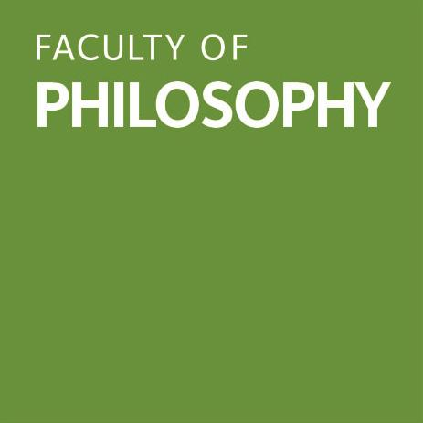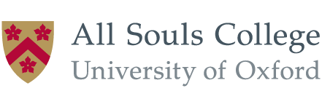

In collaboration with Philiminality Oxford
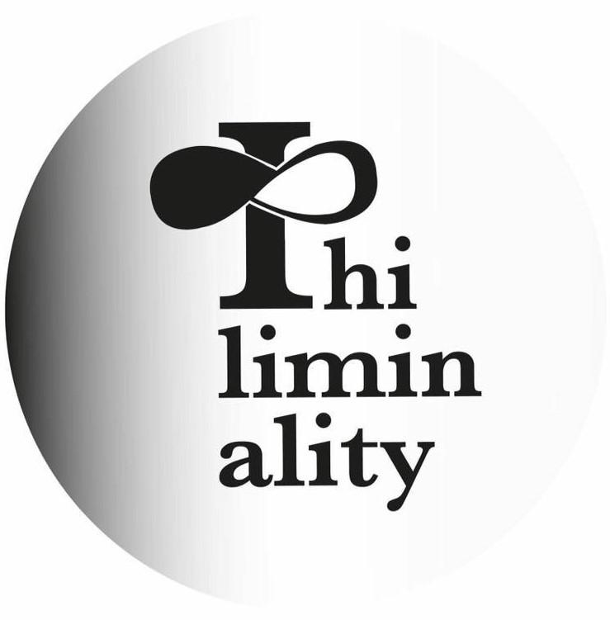

Programme [In-Person Attendance]

Day 1: Friday 28th April 2023

14:00-14:30 Registration (Sultan Nazrin Shah Centre Foyer, Worcester College)
14:30-15:00 Introductory remarks (Sultan Nazrin Shah Centre Auditorium, Worcester College)

Panel 1 – Contexts & Critiques (SNSC Auditorium)
Chair: Maya Krishnan (Oxford)
15:00-16:00 Prof. Lucy Allais (Johns Hopkins, US / Witwatersrand, ZA)
Revisiting Problematising Western Philosophy
16:00-17:00 Prof. Monika Kirloskar-Steinbach​ (Vrije Uni. Amsterdam, NL / Konstanz, DE)
Appropriating, Borrowing, Retelling the Philosophical Story: Countering Conceptual Hegemony
17:00-18:00 Prof. Christoph Schuringa (New College of the Humanities, London, UK)
Canonization and Its Discontents

18:00-19:00 Drinks Reception (SNSC Foyer)
***
Day 2: Saturday 29th April 2023

08:30-09:00 Coffee & Tea Available (SNSC Foyer)

Panel 2 – Historiography A
Chair: Dr Alesia Preite (Oxford)
9:00-10:00 Prof. Robert Bernasconi (Penn State, US)
The Role of Races and Religions in the Rewriting of the History of Philosophy
10:00-10:30 Lea Cantor (Oxford)
The Origin Story of ‘Western Philosophy’
10:30-11:00 Coffee & Tea Break (SNSC Foyer)
11:00-12:00 Prof. Catherine König-Pralong (EHESS Paris, FR)
Mapping (the History of) the Mind. Europe’s Self-Colonization
12:00-12:30 Jonathan Egid (King’s College London, UK)
The category of 'Western Philosophy': reflections from connected history

12:30-13:30 Lunch (SNSC Foyer)

Panel 3 – Individual Figures
Chair: Prof. Ursula Coope (Oxford)
13:30-14:30 Prof. Lin Ma (Renmin, Beijing, CN)
Heidegger on the Abendland and the abendländische Philosophie
14:30-15:00 Dr Saloni de Souza (University College London, UK)
On Top of the World: Garcia de Orta on the Problems With “Western Philosophy”
15:00-15:30 Dr Lilith W. Lee (Vrije Universiteit Amsterdam, NL) ​
Philosophising under King and Qing: Two Straits Chinese Critiques of ‘Western’ Philosophy’

15:30-16:00 Coffee & Tea Break (SNSC Foyer)

Panel 4 – Historiography B (All speakers on this panel will be joining by video link / online)
Co-Chairs: Lea Cantor (Oxford) / Dr Josh Platzky Miller (Free State)
16:00-17:00 Prof. Peter Adamson (Ludwig Maximilian University Munich, DE / King’s College London, UK)
Is Philosophy in the Islamic World “Western”?
17:00-17:30 Dr Dmitri Levitin (Oxford)
The Strange Scholarly Origins of ‘Western Philosophy’, and an Uncomfortable Question
17:30-18:30 Prof. Souleymane Bachir Diagne (Columbia, US)
Translation and African philosophy

​18h30: Day End

***
Day 3: Sunday 30th April 2023

08:30-09:00 Coffee & Tea Available (SNSC Foyer)

Panel 5 – Inclusions & Exclusions
Chair: Prof. Faridah Zaman (Oxford)
9:00-10:00 Dr Yoko Arisaka (Hildesheim, DE)
Hermeneutics of Exclusion: Historiographies of the Histories of Philosophies
10:00-10:30 Dr Daniel J. Smith (Memphis, US)
A Kantian Conspiracy in the Historiography of Philosophy
10:30-11:00 Coffee & Tea Break (SNSC Foyer)
11:00-11:30 Sarah Bernard-Granger (ENS de Lyon, FR)
Western philosophy, or the national construction of a universal philosophy
11:30-12:00 Lerato Posholi (Basel, CH)
Demarcating ‘Western philosophy’: beyond origins?

12:00-13:00 Lunch (SNSC Foyer)

Panel 6 – Traditions & Canons
Chair: Justin Holder (Oxford)
13:00-14:00 Prof. Lewis Gordon (Connecticut, US)
Before ‘the West’ and Beyond: Ancient African and Contemporary Africana Philosophy
14:00-14:30 Kadir Filiz (Radboud University Nijmegen, NL)
Must Phenomenology Remain European?
14:30-15:30 Dr Kimberly Ann Harris (Virginia, US)
The Relationship between African-American Philosophy and ‘Western Philosophy’

15:30-16:00 Coffee & Tea Break (SNSC Foyer)

Panel 7 – Epistemology
Chair: Prof. Luca Castagnoli (Oxford)
16:00-16:30 Dr Josh Platzky Miller (Free State, ZA)
Shirking Knowledge: Forms of Ignorance and the idea of ‘Western Philosophy’
16:30-17:00 Allan M. Hillani (New School for Social Research, US)
Savage Hobbes: Anthropological Philosophy Against Philosophical Anthropology
17:00-18:00 Prof. Linda Martín Alcoff (Hunter College / Graduate Center, CUNY, US)
What comes after Eurocentrism?

18:00-18:30 Closing
19:00 Post-Conference Informal Pub (Jude the Obscure, 54 Walton St, OX2 6AE)
***
Organizers: Lea Cantor (Oxford) & Josh Platzky Miller (Free State)
Assistant organizers: Sihao Chew (Oxford), Jonathan Egid (King’s College London), Dmitri Levitin (Oxford), & alicehank winham (Oxford). In collaboration with Philiminality Oxford.

- Call for Abstracts (note: prior to all funders having confirmed)

Questioning ‘Western Philosophy’: Philosophical, Historical, and Historiographical Challenges

Conference, 28-30 April 2023, University of Oxford
Call for Abstracts. Deadline: 30 October 2022

Confirmed invited speakers:
- Peter Adamson (LMU, Munich/King’s College London)
- Lucy Allais (Johns Hopkins/ Witwatersrand)
- Yoko Arisaka (Hildesheim)
- Robert Bernasconi (Penn State)
- Souleymane Bachir Diagne (Columbia)
- Lin MA (Renmin, Beijing)
- Lewis Gordon (Connecticut)
- Linda Martín Alcoff (Hunter College/Graduate Centre, CUNY)
- Kimberly Ann Harris (Virginia)
- Monika Kirloskar-Steinbach (Vrije Universiteit Amsterdam)
- Catherine König-Pralong (EHESS Paris)
- Christoph Schuringa (New College of the Humanities, London)

We are excited to invite proposals for papers to be given at an international conference, organized in collaboration with Philiminality Oxford, entitled ‘Questioning ‘Western Philosophy’: Philosophical, Historical, and Historiographical Challenges’. The idea of ‘Western Philosophy’ has become pervasive in academia and beyond, and yet what the term refers to is often left vague. Moreover, few scholars have directly explored the idea’s conceptual and historical underpinnings. Questioning ‘Western Philosophy’ will be the first international conference that subjects this idea to critical interrogation, asking whether it is legitimate, where it originates, when and how it becomes widespread, and how it impacts our understanding of philosophy and its history.

The conference will explore the ‘legitimacy debates’ which have thus far been reserved for so-called ‘non-Western’ philosophical traditions, to ask whether the idea of ‘Western Philosophy’ is a legitimate one, rather than simply assuming that it is – and is tantamount to philosophy as such. This might involve interrogating the linear narrative that presents the history of philosophy as a continuous, progressive, self-standing development from the ancient Greeks to contemporary Euro-America. We thus welcome discussion about how entanglements between philosophy in Europe and the rest of the world have a bearing on the notion of ‘Western Philosophy’. Recent scholarship has highlighted the erasure of African and Asian philosophical sources, starting in 18th century European historiography, and its repainting of philosophy as purely European and White, while others have highlighted the erasure of women from the history of philosophy across Europe over the same period. Through the conference presentations, we hope to develop a clearer picture of how these dynamics shaped or even grounded the idea of ‘Western Philosophy’ which emerged over the 19th and 20th centuries. The conference also seeks to explore the impact of colonialism and how its legacies have contributed to the construction of ‘Western Philosophy’. We anticipate critical debates about the origins and rapid ascendancy of the idea of ‘Western Philosophy’, opening new directions in scholarship that pinpoints key moments in the genealogy and dissemination of the idea itself.

Organizers:
Lea Cantor (Oxford) - lea.cantor[twirly at symbol]philosophy.ox.ac.uk
Josh Platzky Miller (KwaZulu-Natal/Cambridge) - millerj[twirly at symbol]ukzn.ac.za

Conference venue & Accessibility: Sultan Nazrin Shah Centre, Worcester College, University of Oxford, UK. Fully wheelchair accessible. PA system with handheld and lapel microphone units, infrared hearing system.

We welcome abstracts that address topics related to the issues outlined above, including:
- Conceptual engagement with the idea of ‘Western Philosophy’, including
  - Intersectional analyses of the construction of ‘Western Philosophy’, especially regarding nationalism, racism, and sexism
  - Engagements with (assumed) characteristics and presuppositions of ‘Western Philosophy’
  - Epistemologies of Ignorance and ‘Western Philosophy’
  - Decolonial and anti-colonial approaches to the idea of ‘Western Philosophy’
  - Comparative and Intercultural approaches to the idea of ‘Western Philosophy’
  - Genealogical approaches to the idea of ‘Western Philosophy’
- Historical and Historiographical analyses of ‘Western Philosophy’, including
  - The origin of the idea of ‘Western Philosophy’
  - How the idea of ‘Western Philosophy’ was popularized
  - Intellectual influences and entanglements between ‘canonical’ European thinkers and contexts/ideas/thinkers outside of Europe, and their implications for the idea of ‘Western Philosophy’
  - Historical critiques and defences of the idea of ‘Western Philosophy’ (especially its earliest promoters and critics from around the world)
- The impact of the idea of ‘Western Philosophy’ on, inter alia,
  - The history and historiography of philosophy
  - Teaching philosophy
  - Philosophical research
  - Public and popular understanding of philosophy and its history

Eligibility & submission guidelines:
We invite abstracts of maximum 500 words from graduate students and Early Career Scholars (within 5 years of PhD completion), suitable for 20-minute presentations in English. We especially encourage submissions from members of underrepresented groups in philosophy, particularly scholars from/in the Global South. Please submit abstracts as a .PDF file in an email attachment to questionwesternphilosophy[at]protonmail.com by 30 October 2022. Please write ‘Conference Abstract Submission’ in the subject line of your email and include your name, departmental affiliation (if relevant), email address, and the title of your paper (Early Career Researchers: please include the year in which your PhD was awarded) in your email. Abstracts should be prepared for blind review, so please ensure that your abstract is free from any identifying personal details (i.e. including title and abstract, but no information about author or institutional affiliation). Decisions will be communicated by 30 November 2022.

Contact:
For more information and updates, please visit our conference website.
For any inquiries, please contact one of the organizers directly. If you wish to be kept informed about the conference (and how to attend), please register your interest here.

This conference is generously supported by the Mind Association, the British Society for the History of Philosophy, and the Aristotelian Society.

- Publicity Sample: Poster

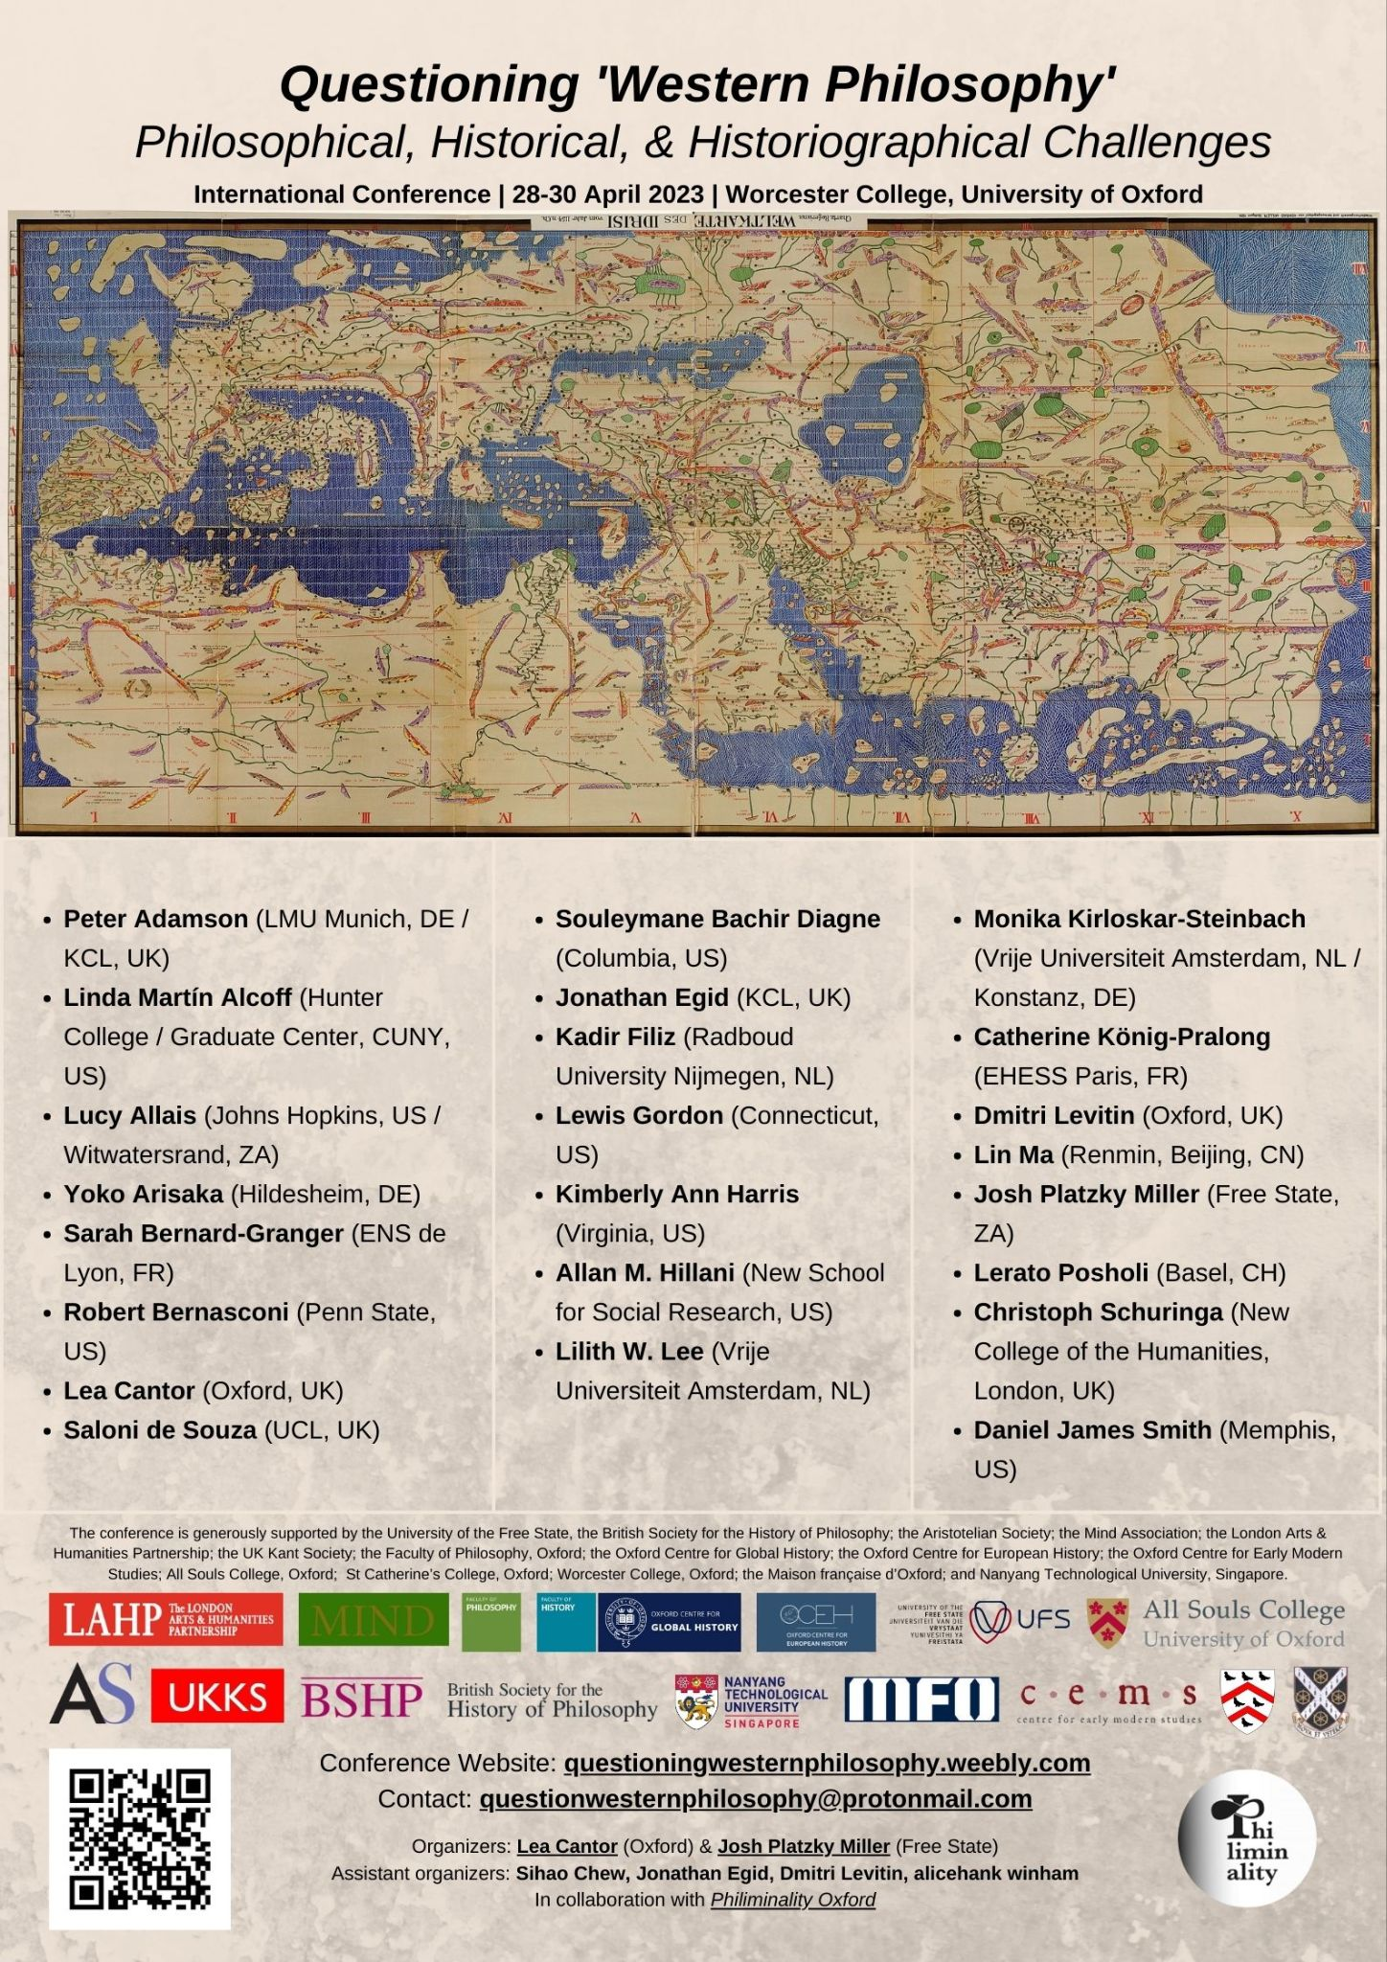

- Registration form clearly displaying any registration fees levied

The registration form (https://www.oxforduniversitystores.co.uk/conferences-and-events/philosophy-faculty/events/questioning-%E2%80%98western-philosophy%E2%80%99-philosophical-historical-and-historiographical-challenges) has been removed from the University of Oxford online store since the event has now taken place.
The registration fee for faculty members and members of the public was set at £20; for students it was set at £10.
We sold 37 student tickets; 9 faculty tickets; and 8 tickets to members of the public.

The conference website continues to display this information clearly:
https://questioningwesternphilosophy.weebly.com/registration.html
It also includes a link to the registration form for online-only attendance (free).

- Photos

A full photo album has been uploaded here: https://philiminalityoxford.wordpress.com/gallery/

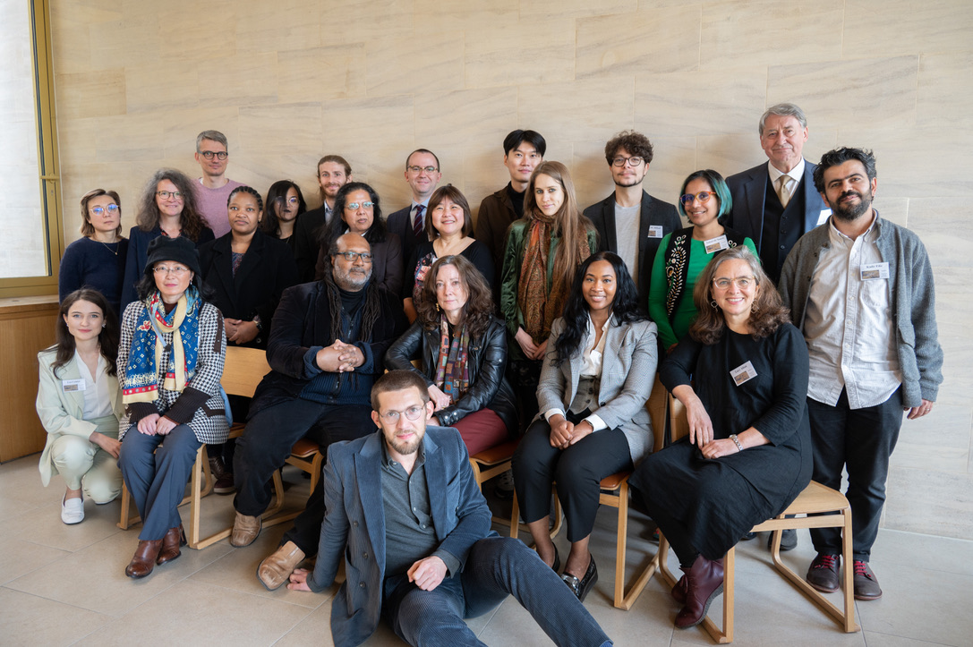

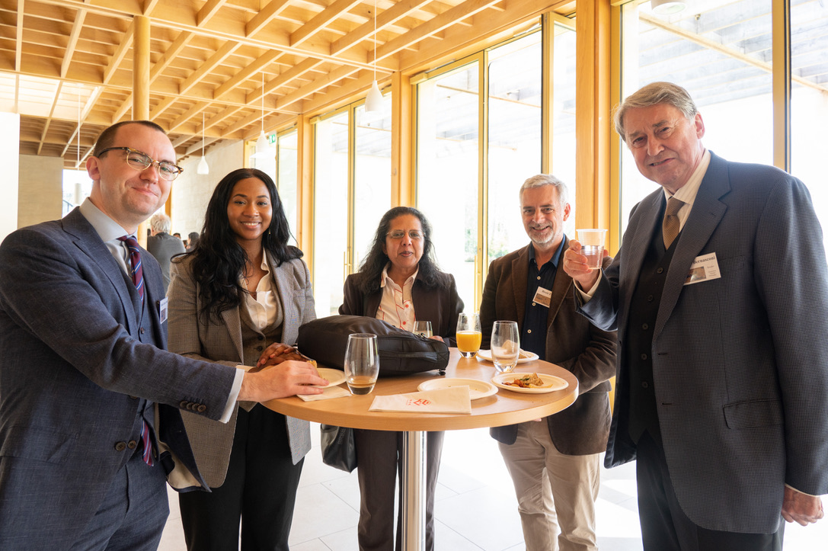

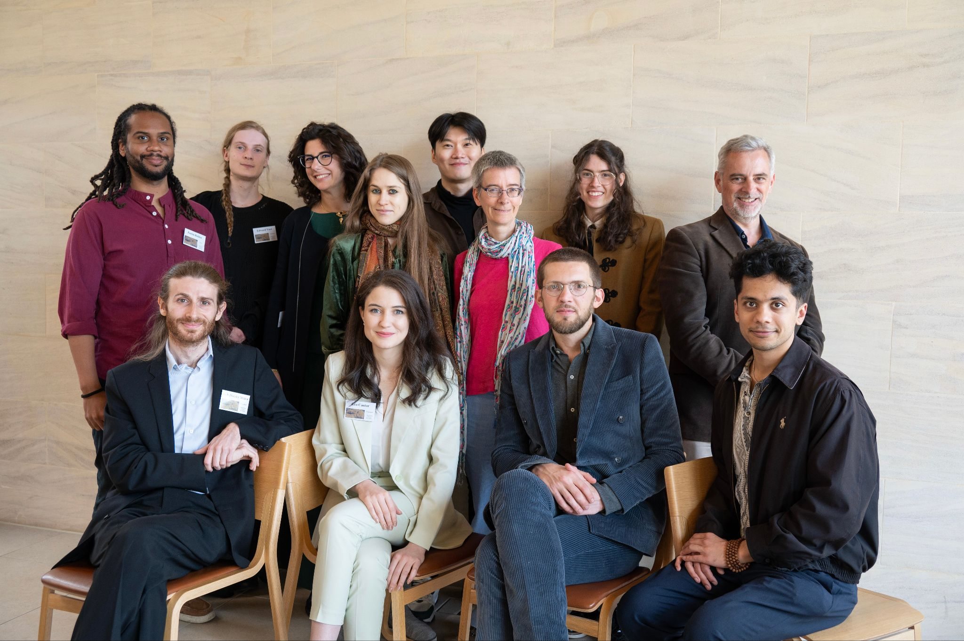

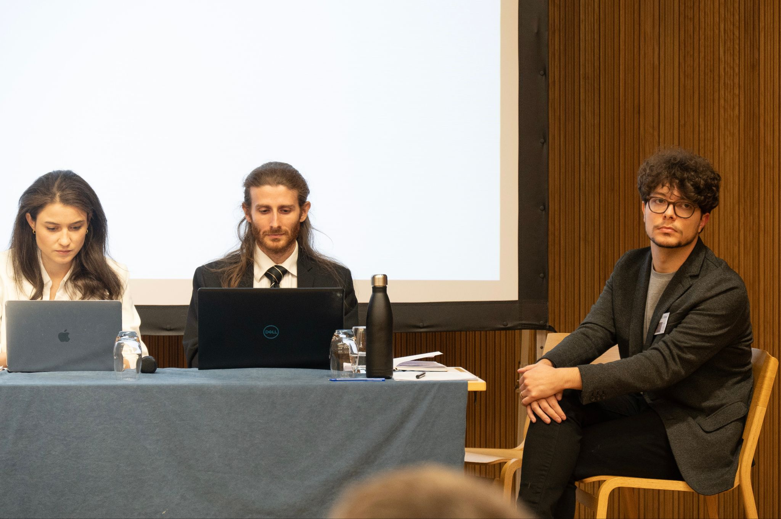

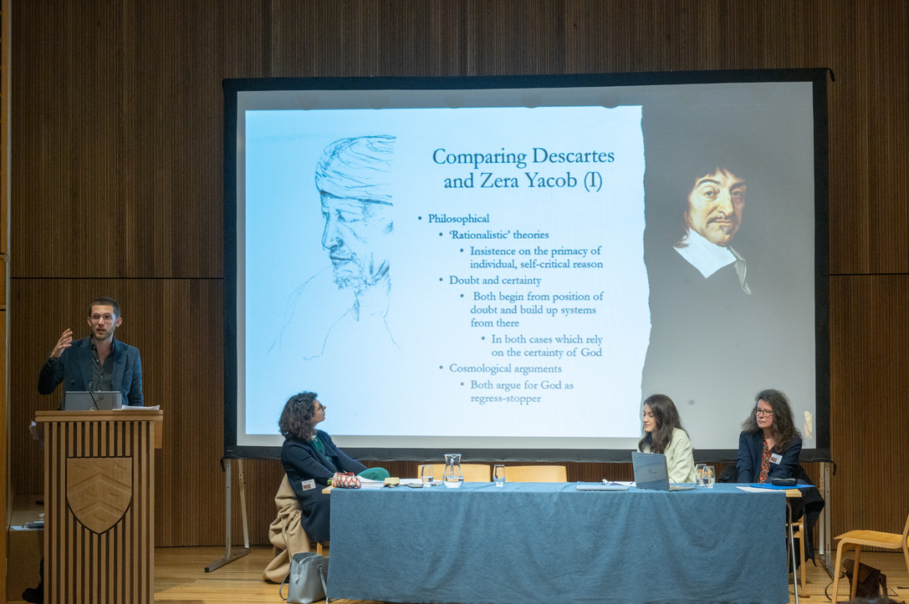

Due to the nature of the conference, many of our speakers had to travel internationally. We encouraged international speakers to attend other conferences while in the UK/Europe, and although several needed to return home immediately afterwards, we are pleased that several other speakers did ‘double-up’. We also enabled three speakers to join online, all on one panel (Panel 4). Many of our speakers took lower-emission public transport (buses/trains) to attend.

